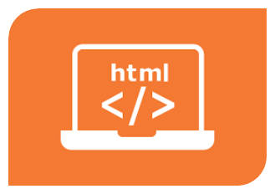

# HTML Tutorial

HTML is the standard markup language for

Web pages.

With HTML you can create your own

Website.

HTML is easy to learn – You will enjoy it!

Prepared by: “Sheryar Sher”

Roll No: “21P8027”

Section: “BS-CS”

Session: “Fall”

Table of Contents

HTML Tutorial 1

1. HTML Introduction (Heading 1) 3

What is HTML? (Heading 2) 3

A Simple HTML Document (Heading 2) 3

Example (Heading 3) 3

Example Explained (Heading 3) 3

2. What is an HTML Element? (Heading 1) 4

3. MS Word Review Tab (Heading 1) 5

Attached the screenshot of Work Count in your document, select it and 5

go to Picture Format tab (Heading 2) 5

Apply Brightness +20%/Contrast -20% (Heading 3) 5

Attached the screenshot of your MS Word Document 5

File properties, select it and go to Picture Format tab 5

(Heading 2) 5

Apply Sharpen +50% (Heading 3) 5

# HTML Introduction (Heading 1)

## What is HTML? (Heading 2)

* HTML stands for Hyper Text Markup Language
* HTML is the standard markup language for creating Web pages
* HTML describes the structure of a Web page
* HTML consists of a series of elements
* HTML elements tell the browser how to display the content
* HTML elements label pieces of content such as "this is a heading", "this is a paragraph", "this is a link", etc.

## A Simple HTML Document (Heading 2)

### Example (Heading 3)

<!DOCTYPE html>  
<html>  
<head> <title>Page Title</title> </head>  
<body>  
  
<h1>This is a Heading</h1>  
<p>This is a paragraph.</p>  
  
</body>  
</html>

### Example Explained (Heading 3)

* The <!DOCTYPE html> declaration defines that this document is an

HTML5 document

* The <html> element is the root element of an HTML page
* The <head> element contains meta information about the HTML page
* The <title> element specifies a title for the HTML page (which is shown in
* the browser's title bar or in the page's tab)
* The <body> element defines the document's body, and is a container for
* all the visible contents, such as headings, paragraphs, images,
* hyperlinks, tables, lists, etc.
* The <h1> element defines a large heading
* The <p> element defines a paragraph

# What is an HTML Element? (Heading 1)

An HTML element is defined by a start tag, some content, and an end tag:

<tagname>Content goes here...</tagname>

The HTML **element** is everything from the start tag to the end tag:

<h1>My First Heading</h1>

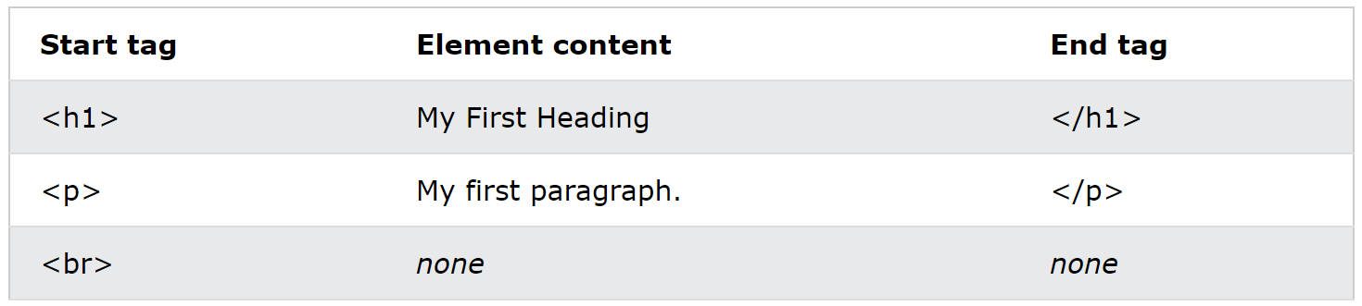<p>My first paragraph.</p>

**Note:** Some HTML elements have no content (like the <br> element). These elements are called empty elements. Empty elements do not have an end tag!

# MS Word Review Tab (Heading 1)

## Attached the screenshot of Work Count in your document, select it and

## go to Picture Format tab (Heading 2)

### Apply Brightness +20%/Contrast -20% (Heading 3)

## Attached the screenshot of your MS Word

## Document file properties, select it and go to

## Picture Format tab (Heading 2)

### Apply Sharpen +50% (Heading 3)